Learn system design

<https://javarevisited.blogspot.com/2022/08/top-7-websites-to-learn-system-design.html?utm_source=dlvr.it&utm_medium=facebook#axzz7xBmGe7hY>

### **1. Udemy [Best Platform for System Design Course]**

This is a wonderful website that will teach you everything you need to know about system designing along with grokking from absolute scratch. In this way, it is absolutely perfect for complete beginners. Udemy is a perfect starting guide for beginners looking to enter the amazing world of system design.

Using this fantastic website, you will learn about all the core features of advanced system design. You will also become a very advanced system designer. You will be able to master both system design and grokking.

Powered ByVDO.AI

### **[10 Examples of cURL command in UNIX and Linux](https://javarevisited.blogspot.com/2017/03/10-examples-of-curl-command-in-unix-and-Linux.html?utm_campaign=s-javarevisited-blogspot&utm_medium=recirculation&utm_source=vdoai_stories)**

### **[Top 5 Books to Learn DevOps for Developers - Best of Lot](https://javarevisited.blogspot.com/2020/04/top-5-books-to-learn-devops-for-developers.html?utm_campaign=s-javarevisited-blogspot&utm_medium=recirculation&utm_source=vdoai_stories)**

### **[10 examples of grep command in UNIX and Linux](https://javarevisited.blogspot.com/2011/06/10-examples-of-grep-command-in-unix-and.html?utm_campaign=s-javarevisited-blogspot&utm_medium=recirculation&utm_source=vdoai_stories)**

### **[Top 5 Courses to Learn Eclipse IDE for Java Programmers - Best of Lot](https://javarevisited.blogspot.com/2020/05/top-5-courses-to-learn-eclipse-ide-for-java-developers.html?utm_campaign=s-javarevisited-blogspot&utm_medium=recirculation&utm_source=vdoai_stories)**

Here are the **best System design courses from Udemy** which are worth looking:

* [Mastering the System Design Interview](https://click.linksynergy.com/deeplink?id=JVFxdTr9V80&mid=39197&murl=https%3A%2F%2Fwww.udemy.com%2Fcourse%2Fsystem-design-interview-prep%2F)
* [Pragmatic System Design](https://click.linksynergy.com/deeplink?id=JVFxdTr9V80&mid=39197&murl=https%3A%2F%2Fwww.udemy.com%2Fcourse%2Fpragmatic-system-design%2F)
* [System Design Interview Guide by Sandeep Kaul (Tech Lead @ Facebook)](https://click.linksynergy.com/deeplink?id=JVFxdTr9V80&mid=39197&murl=https%3A%2F%2Fwww.udemy.com%2Fcourse%2Fsystem-design-a-comprehensive-guide%2F)

By the time you finish all the courses on Udemy, you will become an expert system designer and also be ready to solve those complex System design problems like how to design YouTube, Instagram, WhatsApp or a messaging queue.

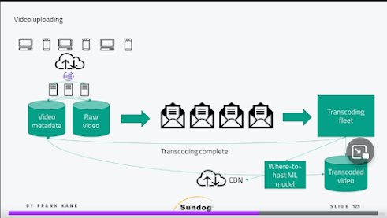

### **2. Educative [Interactive System Design Platform]**

Educative is one of my favorite for learning system design on the internet right now. It is basically a website that has been literally created to prepare you for a system design interview. Through this website, you will also get an idea of how to approach system design in general.

It is also one of the only websites out there that will teach you about large-scale distributed system design problems in painstaking detail. It does not matter even if you are an expert in the field. I am pretty sure that you will find this website a valuable learning experience.

The smart people who have created this website have also gone the extra mile to give you a list of design choices. This list will make you understand the requirement, compare different approaches, and finally come up with a suitable solution for the complex problem that you are facing.

Here are the **best System Design Courses from Educative.io**:

* [Grokking the System Design Interview](https://www.educative.io/collection/5668639101419520/5649050225344512?affiliate_id=5073518643380224)
* [Grokking the Advanced System Design Interview](https://www.educative.io/courses/grokking-adv-system-design-intvw?affiliate_id=5073518643380224)
* [Grokking Modern System Design for Software Engineers & Managers](https://www.educative.io/courses/grokking-modern-system-design-software-engineers-managers?affiliate_id=5073518643380224)

What makes Educative really interesting is also the fact that the instructors do not spoon-feed you anything. You are required to work on the problem and come up with innovative solutions yourself. If you are looking for just one website that will thoroughly prepare you for a system design interview, you do not need to look any further.

Here is a nice System Design Cheat Sheet from Educative for quick revision:

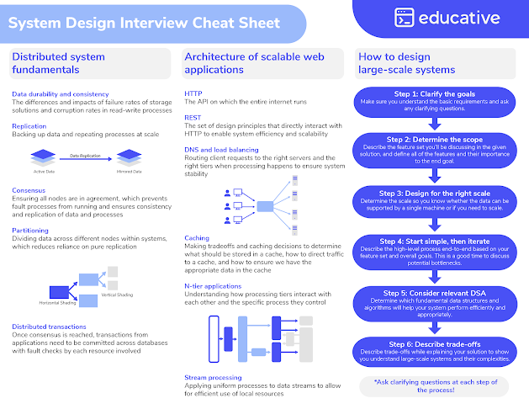

The instructors on Educative will also share with you their first-hand experiences on how to solve a complex system design problem. You will learn about all *the different tips, tricks, concepts, and approaches for solving system design questions* in general.

You will also have the opportunity to practice a lot of classic system design problems like the web crawler, [URL shortener](https://www.educative.io/courses/grokking-the-system-design-interview/m2ygV4E81AR?affiliate_id=5073518643380224), and designing a restaurant reservation system.

These System Design courses on Educative will teach you about different techniques that are useful for scaling distributed systems. You will get an overview of database technologies and NoSQL solutions. In addition, you will also learn how to use caching for improving scalability and performance.

By the way, you can either join this course individually or you can take an [**Educative Unlimited subscription**](https://www.educative.io/subscription?affiliate_id=5073518643380224) for just $14.9 per month on annual plan (recommended) to get access to their 350+ high quality, text-based, interactive courses to learn key skills for coding interviews, software development, and technology.

### **3. ByteByteGo by Alex Yu**

This is another amazing platform to learn about System design concepts and also prepare for System Design Interview. This website is created by Alex Yu, author of popular [**System Design Interview – An insider's guide**](https://www.amazon.com/System-Design-Interview-insiders-Second/dp/B08CMF2CQF/?tag=javamysqlanta-20) books, one of the most recommend books for System Design interview. This website also serves as the digital version of his book but it offers much more than that. '

Alex has shared detailed, step by step framework to solve system design questions from interviews like How to design YouTube and How to design a chat system. He also regular share interesting content on System Design which are quite useful to learn about essential System design concepts like scaling, caching and distribute messaging.

If you are preparing for System design interview then I highly recommend you to checkout this website and join his course. You can also use code JALJAD to get 10% discount, specially secured for Javarevisited reader.

Here is the link to join this course - [**10% discount on ByteByteGo**](https://bytebytego.com?fpr=javarevisited)

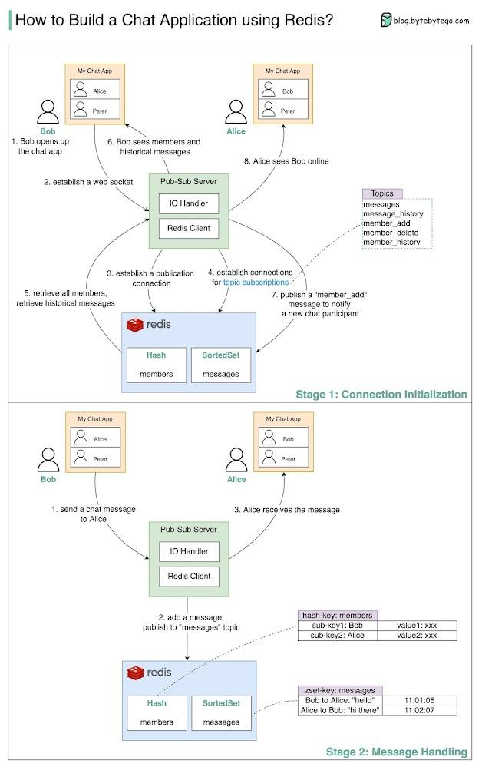

### **4. Exponent**

This is another great website to learn about System design and prepare for System design interview, especial for FAANG companies. There [System Design Interview Course](https://www.tryexponent.com/courses/system-design-interview?ref=javinpaul2) has 36 lessons and it provides solutions of system design questions like Design Twitter, Instagram, Parking lot, design a Web Crawler, and many other popular Software design questions.

They also have dedicated course for different FAANG companies, For example they have a dedicate course for Amazon SDE interview which not only prepare you for tech round but also conduct mock interviews to check your actual preparation level. They also have a similar courses for Google interview as well.

The best thing I liked about Exponent is their mock interviews which is like real drill as well 1-to-1 coaching and interactive discussion on popular interview questions from Google, Facebook, Microsoft and Amazon,

If you are preparing for System design interviews on FAANG companies then I highly recommend this course and website and you can join them for just $12 a month now (70% discount).

Here is the link to join Exponent - [**Try Exponent now**](https://www.tryexponent.com/courses/system-design-interview?ref=javinpaul2)

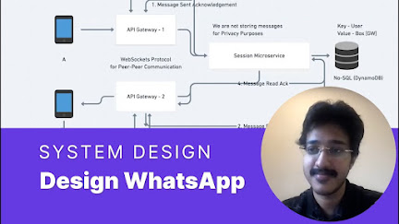

### **5. Coursera**

Coursera is another awesome place to learn in-demand tech skill online. The best thing about Coursera is that their course materials are designed and delivered by world class universities and top tech companies like Google, AWS, and IBM.

When it comes to Software design, I really liked [**Software Design and Architecture Specialization**](https://coursera.pxf.io/c/3294490/1164545/14726?u=https%3A%2F%2Fwww.coursera.org%2Fspecializations%2Fsoftware-design-architecture)from University of Alberta, which contains a couple of nice courses related to software design.

The fantastic courses on Coursera will act as a great brief introduction to the amazing world of modern system design. It is perfect for beginners as you will learn about system design from absolute scratch. You will learn exactly what system design is and why is it used.

Coursera is also a great choice that will help you take your skills in [object-oriented design](https://medium.com/javarevisited/top-10-object-oriented-analysis-and-design-interview-questions-and-problems-for-experienced-6c3a53b7cb26) to another level. You will be able to do this by using object-oriented system design rather than the traditional system design techniques. The courses on this website will also teach you how to pass your system design interview. You will also learn how to get jobs at Google. Facebook, Microsoft, and Amazon.



By the way, If you are planning to join multiple Coursera courses or specializations, then consider taking a [**Coursera Plus subscription**](https://coursera.pxf.io/c/3294490/1164545/14726?u=https%3A%2F%2Fwww.coursera.org%2Fcourseraplus) which provides you unlimited access to their most popular courses, specialization, professional certificate, and guided projects. It costs around $59/ per month but is worth it because you get access to more than 7000+ courses and projects, and you can also get unlimited certificates.

### **6. LinkedIn Learning**

LinkedIn Learning is an exciting website with a lot of courses that will teach you everything you need to know about the basics of machine learning system design in the shortest time possible. The website will also teach you everything you need to know about machine learning and system design.

On this fantastic website, you will learn everything you need to know about the different components of system design for getting hired by major IT companies. You will start by learning about the basics of system design. Then you will move on to understand what exactly is system design.

Here is the best System design course from LinkedIn Learning

* [**Software Architecture Patterns**](http://linkedin-learning.pxf.io/c/1193463/449670/8005?u=https%3A%2F%2Fwww.linkedin.com%2Flearning%2Fsoftware-architecture-foundations)

By the time you finish all the courses on this website, you will be able to get a very good job at major tech companies.

By the way, you would need a [*LinkedIn Learning membership*](http://linkedin-learning.pxf.io/c/1193463/449670/8005?u=https%3A%2F%2Fwww.linkedin.com%2Flearning%2Fsubscription%2Fproducts) to watch this course which costs around $19.99 per month but you can also watch this course for FREE by taking their 1-month-free-trail which is a great way to explore their 17500+ online courses on the latest technology.

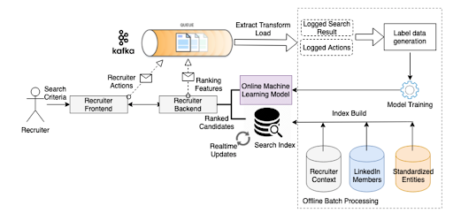

#### 

### **7. Pluralsight**

Pluralsight is a fantastic website that will help you polish your machine learning and system design skills. You will be able to do this by grokking your way to getting a very good machine learning job.

Using the exciting courses on this website, you will also be able to learn the fundamentals of designing in Java.

You will also be able to start your amazing journey by making use of these amazing courses. When it comes to System design, I really liked their [**Patterns for Building Distributed Systems for The Enterprise**](https://pluralsight.pxf.io/c/1193463/424552/7490?u=https%3A%2F%2Fwww.pluralsight.com%2Fcqrs-theory-practice) course, its one of the best Software design course on Pluralsight.

It is perfect for experienced developers In the fantastic courses on Pluralsight, you will learn about all the core features of domain-driven system design, CAP theorem, CQRS etc. You will also become a very advanced system designer. You will be able to master domain-driven system design.



By the way, you would need a Pluralsight membership to join this course which costs around $29 per month or $299 per year (14% discount). I highly recommend this subscription to all programmers as it provides instant access to more than 7000+ online courses to learn any tech skill. Alternatively, you can also use their [**10-day-free-pass**](https://pluralsight.pxf.io/c/1193463/424552/7490?u=https%3A%2F%2Fwww.pluralsight.com%2Fpricing%2Ffree-trial) to watch this course for FREE.

Read more:<https://javarevisited.blogspot.com/2022/08/top-7-websites-to-learn-system-design.html#ixzz7xBs4LD3j>